**How to Read a PPD in eClinicalWorks**

1. Find the patient
2. Look in Yellow Sticky note for follow up information

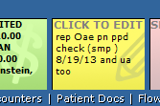

1. Template Note- Use ---PPD Recheck or the one for GHI if appropriate

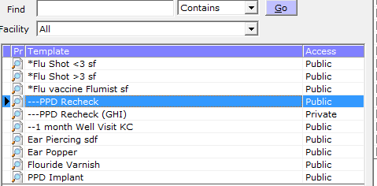

1. Copy template

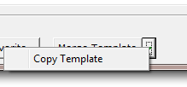

1. Say Yes to Warning Box that Pops Up

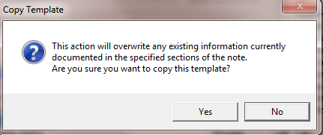

1. Highlight Lab Tab on Right panel

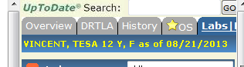

1. Pick PPD and click to open lab

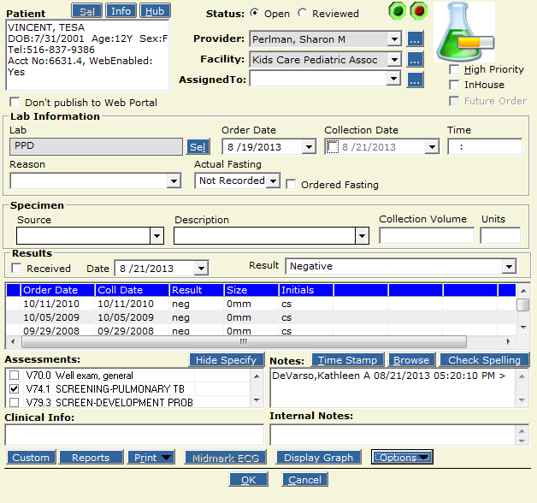

* 1. Check Reviewed
  2. Check Collection Date
  3. Check Received
  4. Enter Result (Negative)
  5. Go to line and enter Neg/0mm/initials as appropriate
  6. Time Stamp
  7. Say OK

1. Go back to lab Tab and click on arrow next to the PPD

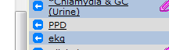

1. Now Go to Billing > Visit Code

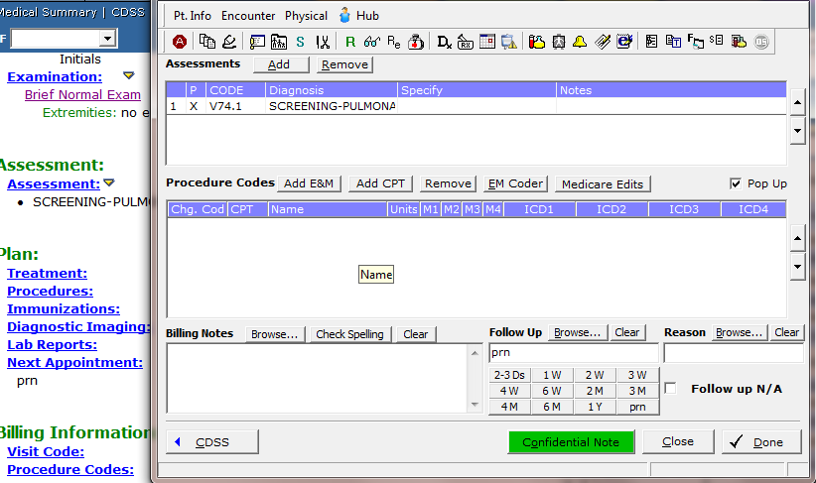

* 1. Add E&M/ follow up and say Done

1. Lock Note

