Follow Up Referral Procedure

Click on the R Jelly Bean

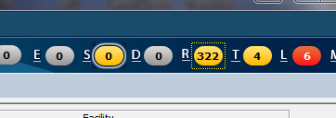

The Window opens, and change settings:

Assigned to : All Referral from : All Dates: go back 2 years All Facilities

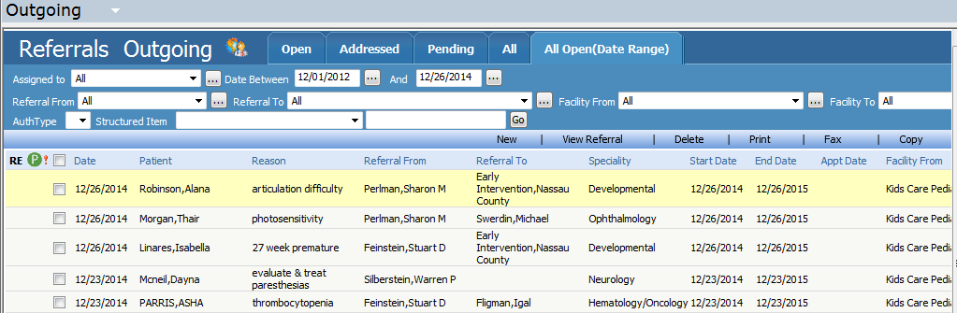

Then re-order the list by dates – click on the date to see oldest first

Look in the patients documents under Consults to see if they went to the Referral by

Click on the Referral 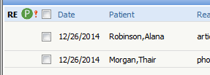

Click on Patient Hub 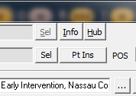

Click on Documents 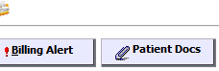

And scroll down to documents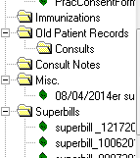

Search for the specialist. **If they were seen by the specialty referred to, then**:

Close windows until you get back to the referral screen

Click on Visit Details: 

Enter an encounter date from the drop down list (closest to referral)

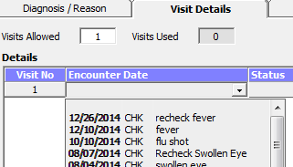

Then Click on the Addressed window, and BAM, the referral goes away.



If they WEREN’T seen (aka there is no notes in the Consult folder then

Call the Doc they were referred to, ask if they were seen, ask for a letter, and put a note in the note section.

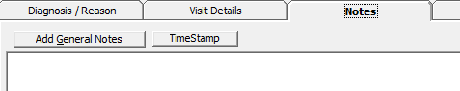

Leave it un-addressed until we get the letter.

If they **Didn’t GO,** put a note in the notes and address it.

Move on to the next one.