Create Recall Postcards

1. On the left side click on the **Registry Band**
2. 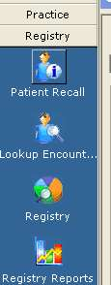
3. Click on **Patient recall**
4. At top click on **Protocol**
5. At right of Protocol Box click on **Misc**

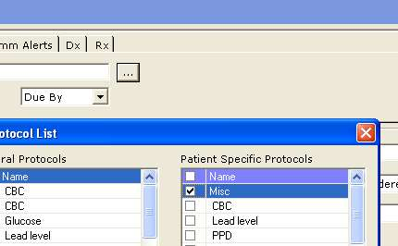

1. Next to dates click on **Date Range[1]**
2. Middle right of the page click on **Lookup:** 
   * 1. This will give you the names of all the people who need recalls.
3. 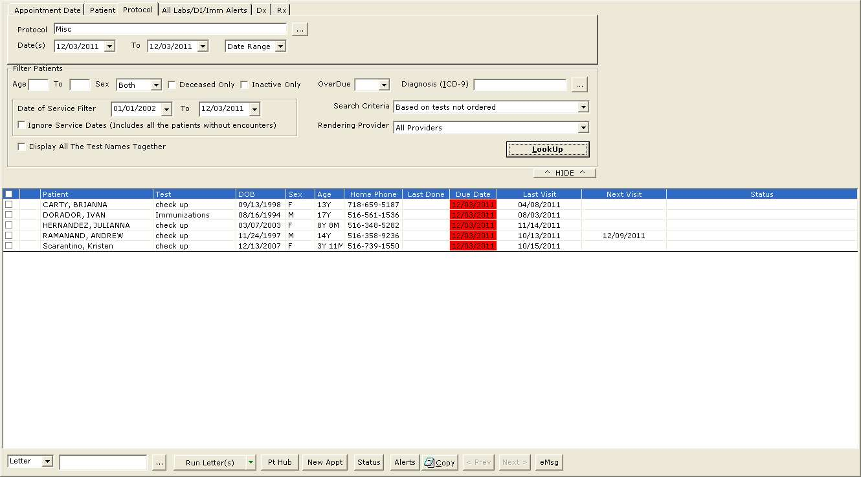
   * 1. However, you need to go to each name to make sure that either they have not already had a check up or that they have one scheduled sometime in the future.
     2. To do this, click on the box next to their name (you can only put a check in one name at a time).
     3. Then click on Pt Hub (bottom middle of page)
     4. Check in Encounters to see if they have had a check up or have one scheduled.
4. (For children over 5 they get one check up every 12 months. For children 2 to 5 years it’s one check up every 6 months. Children 1 to 2 years every 3 months and birth to 1 year every month)
   * 1. If you see that they have already had a check up or have one scheduled, go to alerts at top of hub page, find the date that you want to take out, click on that line then click on suppress, click on yes and click ok. Before you send the cards out you will need to exit ECW and then go back in to erase the suppressed patients.
5. **To Run the RECALL POSTCARD:**
   * 1. Find recall cards in **Letter Template**, (pick the lastest version: -recall postcard Dec2011) click ok,

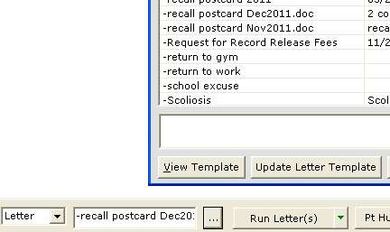

* + 1. Click on Run Letter.
    2. Say yes you want to track the letter. (It will show up in letter logs on patients hub in case they say they never got the card)
    3. Click Form Letter at bottom of the page then print.

1. **To Print the Cards:** choose the HP3005 Printer.
   * 1. To print the card, which is done on the printer at front desk, put a check next to all the names of the first page. (I find it easier to do one page at a time)
     2. When the Printer window comes up, click on properties, then Under **the Paper/Quality** tab, change paper to **recall postcards.** 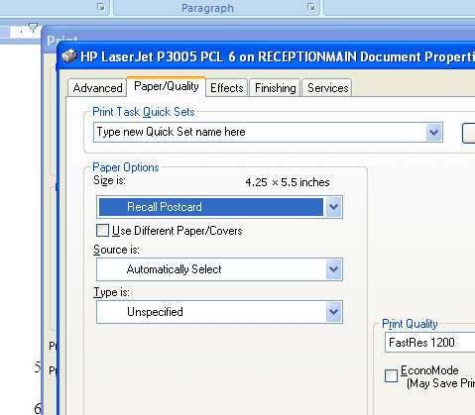
        + 1. The cards go in the front of the HP printer and come out the back, so be sure the back door of the printer is open before you start printing. They sit with the printed picture side down.
          2. **Put the Postcards into Draw 1 lined up towards the left but just tripping the paper detector.**

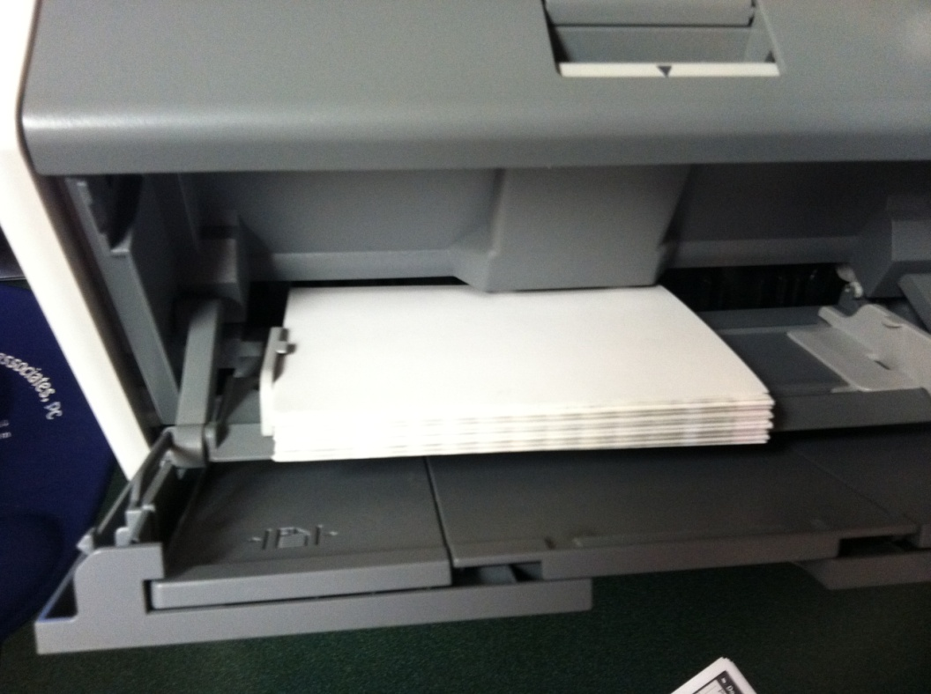

1. When that list is done, uncheck the ones on that page and go to the next page and repeat the procedure until the entire list is completed.

1. I usually do from the first of the month until the 15 or 16 depending on how many days there are in the month.